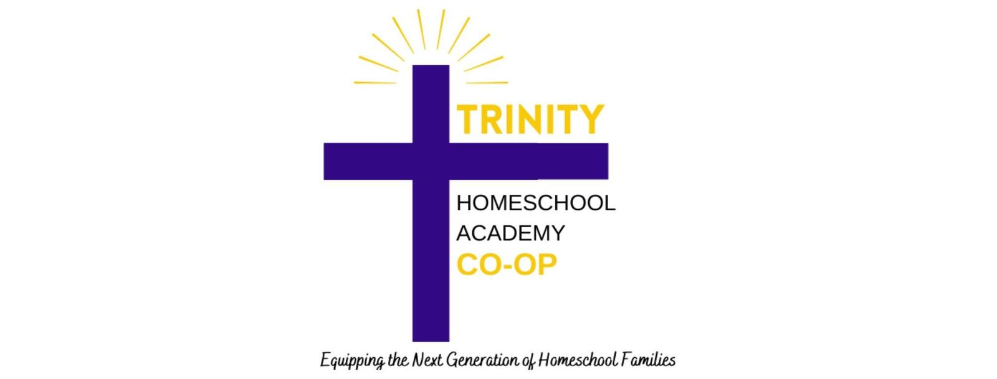
________________________________________________________________________

Authorization and Request
For Criminal Records Verification Information

I____________________________________ hereby authorize THSA to obtain and/or request information about my criminal record history from any identity chosen specifically for conducting this search, to release any information regarding any record of charges or convictions contained in its files, or any criminal file maintained on me, whether said file is local, state or national file, and included but not limited to accusations or convictions of crimes committed against minors, to the fullest extent permitted by city, county, state and federal law. I do release said entities from all liability that may result from any such disclosure made in response to this request. I may revoke this request any time, but that revocation must be in writing and give 30 days’ notice of same.

Please print (for identification purposes):

Full Legal Name:
First Middle Last

Other Names You Have Used in Past Seven Years: ____________

______________________________________________________________________________

Current Address:

Previous Address (most recent):

Phone Number:

Date of Birth: Gender: Female Male

Social Security Number:

Driver’s License #: State of Driver’s License:

Have you ever been convicted of a criminal *offense or have any pending criminal* charges against you?
___________________________________________________________________________
___________________________________________________________________________

*This refers only to felonies and misdemeanors; you do not need to include non-criminal traffic violations or municipal ordinance violations.

Yes (provide detail on next page) No

To the best of my knowledge, the information provided in this Notice and Authorization and any attachments thereto is true and complete. By signing below, I hereby provide my authorization to THSA to conduct a criminal background.

Signature Date

